RepRapPro Inkjet – Instructions – General Notes
-20/07/2015

Principle
The HP51604A inkjet cartridge is a thermal inkjet, with 12 nozzles on the print head. Each nozzle has an accompanying 65 ohm resistor. The nozzles are small enough that the surface tension of the ink will prevent droplets flowing out under normal circumstances. When a voltage pulse is applied to a nozzle connection the resistor heats up, rapidly boiling a small amount of ink around the resistor. This bubble forces a small droplet of ink out of the nozzle.

Because the inkjet head has 12 nozzles, arranged in a line, an image can be produced 12 pixels at a time. Typical operation would sweep the print head along a line, firing nozzles as required to produce a line of the image, 12 pixels thick. The print head would then be moved down, and the next line drawn. This technique greatly decreases print time, compared to if only a single nozzle was used.

Pin Connections
The diagram below shows the pin connection diagram for the inkjet breakout PCB. The numbers refer to the nozzles on the inkjet, with nozzle 1 being closest to the connector, and 12 being furthest. The +V connection is common to all nozzles.
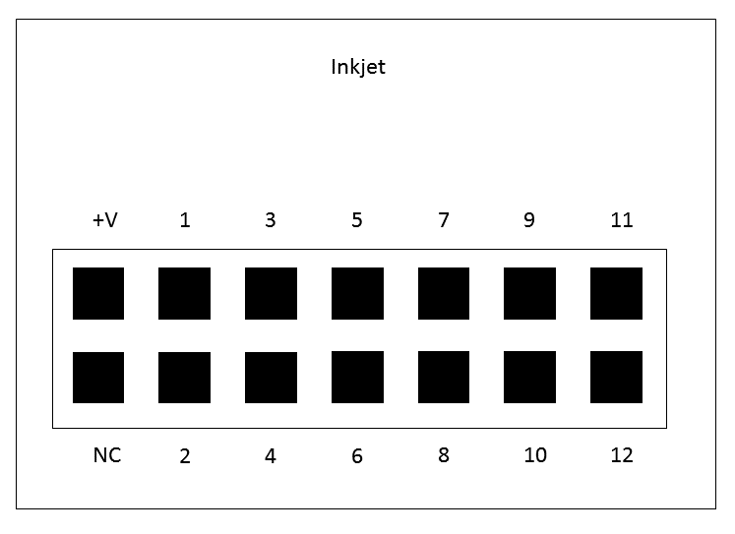

Driver Electronics
The inkjet requires a supply voltage of around 20V. A typical circuit would have the common connection of the cartridge at 20V, and each nozzle line connected to an open drain FET. Pulsing the gate of the FET high will fire the nozzle. Many driver ICs exist that will fulfill this roll. The RepRapPro driver board uses 6B595 shift registers. This IC has open drain outputs, and allows for control of the inkjet with relatively few pins.

The nozzle resistors are very sensitive to the length of the voltage pulse used to trigger them. A pulse too short will not provide enough energy to boil the ink; too long and the resistor will be destroyed, rendering the associated nozzle useless. The recommended amount of energy in the pulse is 40μJ (40 microjoules).

The required pulse length can be calculated using the formula:
Pulse length = Resistance * Energy / (Voltage)^2

The table below lists pulse lengths at various supply voltages:

Voltage (V) | Pulse Length (μs)
19 | 7.2
20 | 6.5
21 | 5.9
22 | 5.4
23 | 4.9
24 | 4.5

Pulses longer than these recommended times have a very real chance of burning out the resistors in the inkjet, so fairly precise timing circuitry is recommended. Arduinos running at 16MHz (like the Uno or Mega) will struggle to produce pulses this short, you may require additional circuitry (e.g. a monostable). Note that the Arduino function delayMicroseconds is not accurate at pulses this short.

An oscilloscope is very useful for checking pulse length is suitable. Whilst you are still testing your circuit, is is recommended that you disconnect the inkjet, until you are sure the pulse is not too long.

It is easy to check if you have burned out the resistors in any of the nozzles, simply by measuring the resistance between the common pin and each nozzle pin. A functioning nozzle will have a 65 ohm resistance. A damaged nozzle with have a resistance of several megohms.

It is important to consider how your circuit behaves when switching on, or having programs uploaded to a microcontroller (e.g. if your system is Arduino based). If you are leaving the inkjet connected, ensure that the driver pins do not get pulsed/made high, as it could burn out the resistors.

Operational Notes
It is recommended that the minimum time between firings for a single nozzle in 800μs. The recommended minimum time between firing different nozzles in 0.5μs.

The minimum distance between the print head and the surface is 0.5mm, although with the 3D printed mount, this is not an issue. It is recommended that the print surface is within about 7mm of the nozzle, but this is quite subjective. The closer the surface is to the nozzle, the higher the print quality. If the inkjet is mounted on a 3D printer, with many fans nearby, having the printhead closer to the surface reduces the effect of airflow disturbing the ink droplets as they are sprayed.

Printed Part Preparation
In order to achieve the best fit, it may be necessary to enlarge the pritned holes slightly. All holes on the lower mount should be enlarged with a 2.5mm drill bit. Holes on the upper mount and cable tidy should be enlarged with a 3mm drill bit. A pin vice or drill chuck are useful for holding the drill bit, but simply holding the drill bit with pliers would also work.

Further Reading
Amberish Jaipuria has written a detailed report on the HP51604A inkjet, with some details on how to drive it. It is available on the RepRapPro github inkjet repository (https://github.com/reprappro/Inkjet/blob/master/AB-design/RepRap-Inkjet.pdf)

An out of print book exists by Matt Gilliand, Inkjet Applications, with detailed information about the HP51604A inkjet.

